4.page layout

When we first come to this page, we can see it directly what is about. And there is an obvious sign which is Association for Computing Machinery at the top of the page, next it to is “Advancing Computing as a Science & Profession”. Then we can clearly see some useful news for people who are interested in this field.

If you know computer machinery, you will very like it.

In the middle of the page, it has a big image concluding computer language and its full name of the website, also has it in the top.

At the top left corner, we can see the navigation and four colorful buttons guiding us what do you want to do, under this is another navigation using black background and white characters.

This web is Association for Computing Machinery named ACM about Advancing Computing as a Science & Profession.

At the footer area we can see how to contact ACM and some useful function.

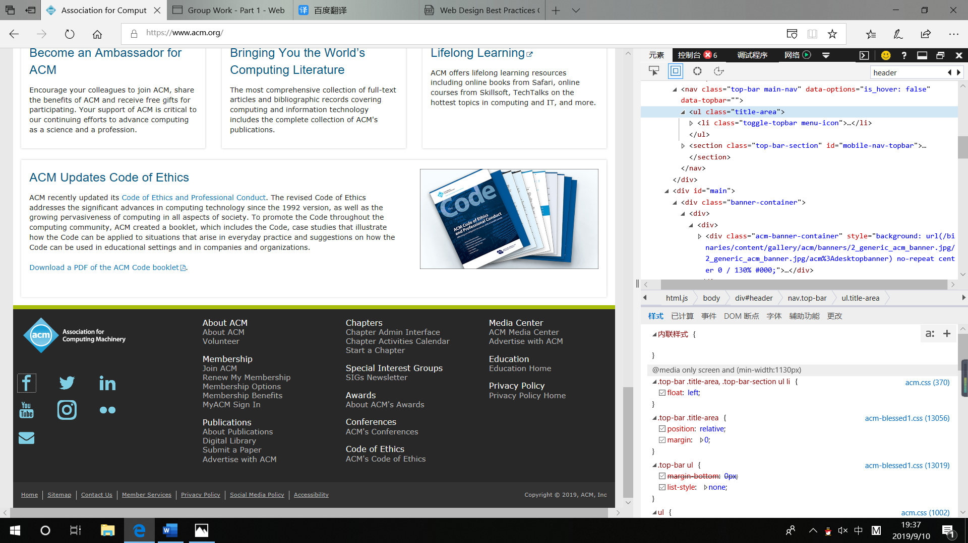

There are other functions:

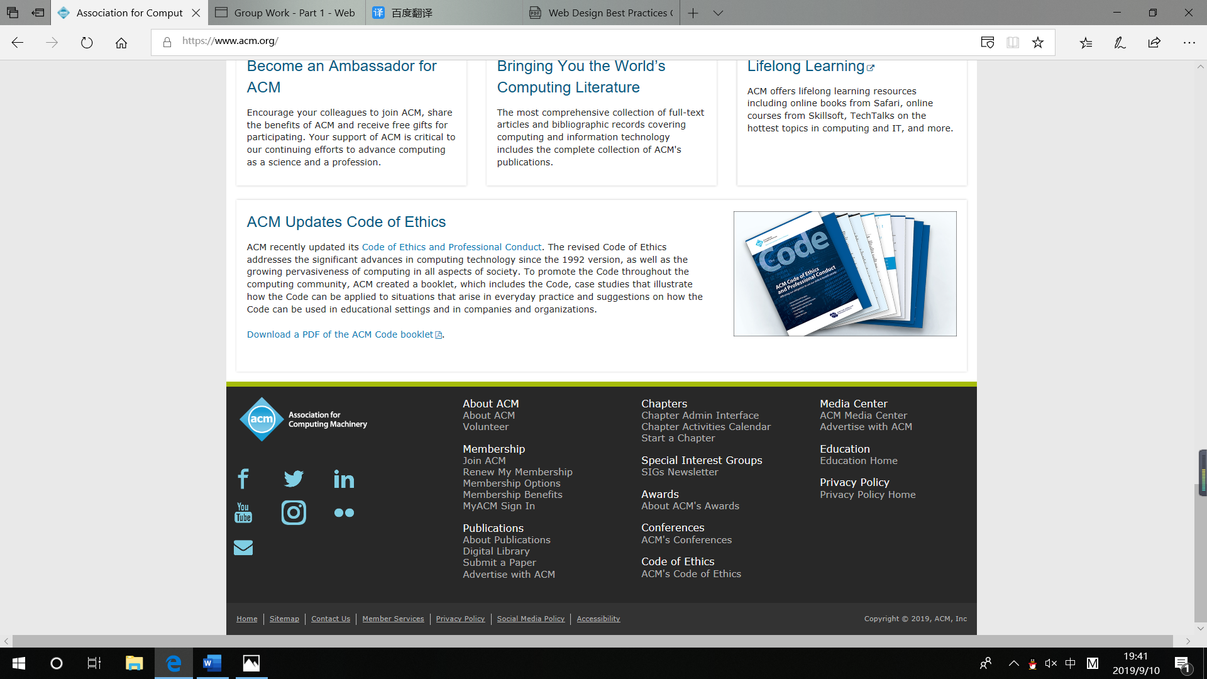

At the left corner it is their copyright belong to ACM,Inc: 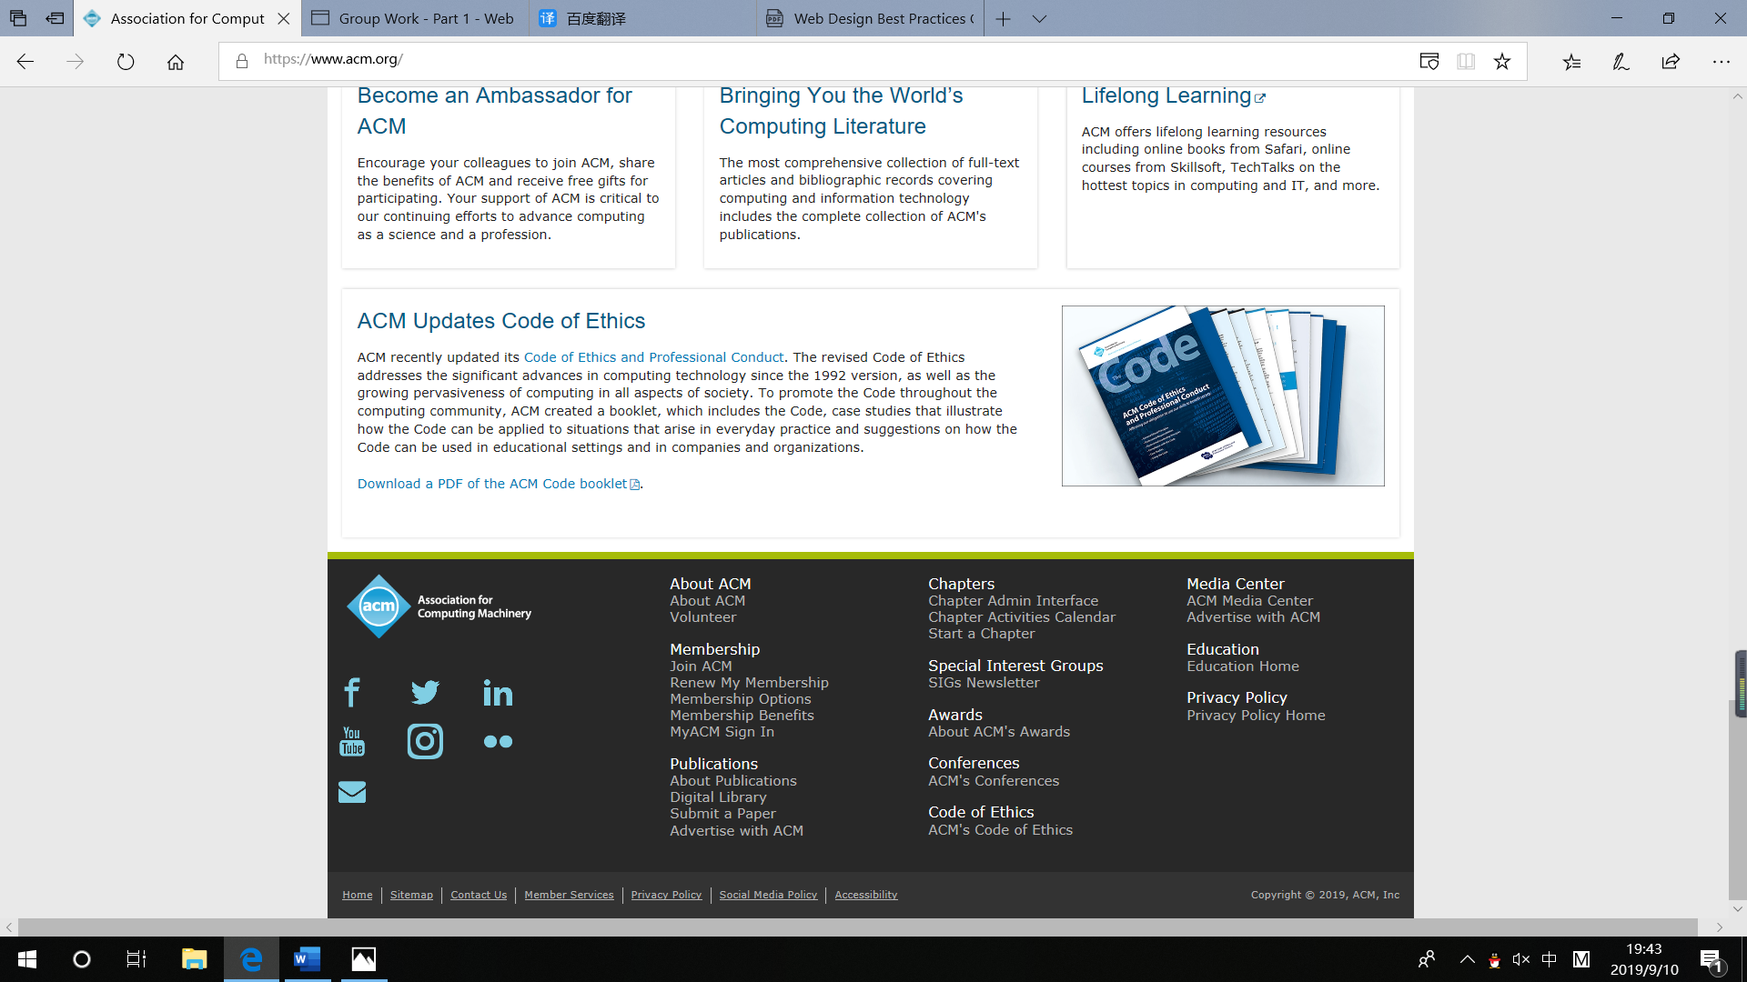

Good use of basic design principles: repetition, contrast and alignmen, to display some important news and catch our attention.

When at 1024×768 or higher resolutions, there is not display the horizontal scrolling.Also it is noticeabliy that header and nav occupy less than ¼ to ⅓ of the browser at 1024×768 resolution and The key parts are more prominent to make it easier for users to get useful information.Then we can some interesting news display in the page and the compelling information.

This site handles the contrast between pictures and text very well, and by adjusting the font color to highlight the key points in the white background, it will not make people look messy. There are also some gaps where the site looks more concise.

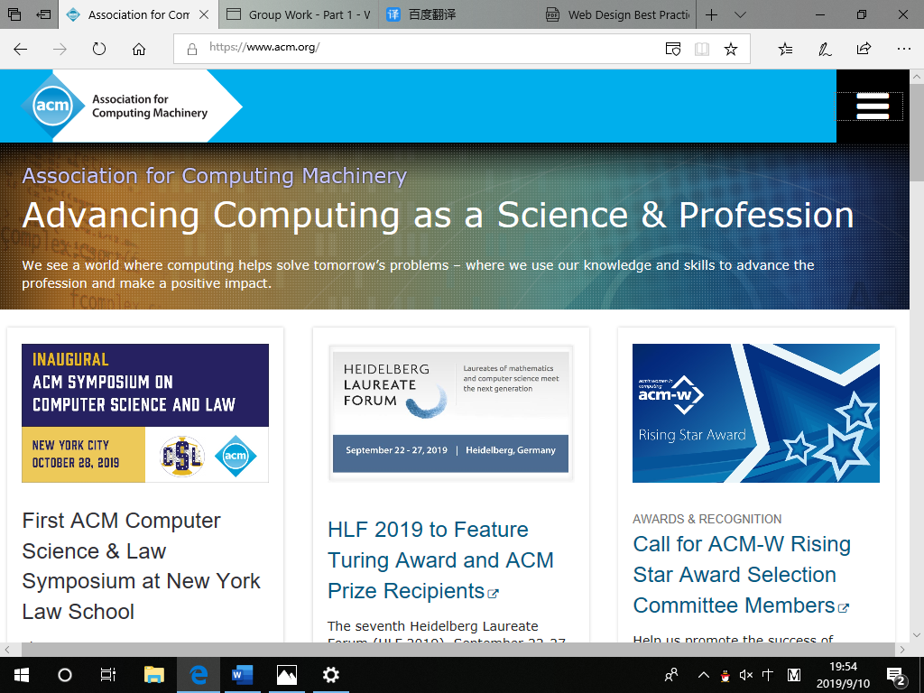

Used to enhance the display effect of smartphones and also configure response page layout for smartphone or tablet display. Automatically adjust page layout when using different mobile phones or tablets.

I think the layout of the site is comfortable and the content is concise and easy to get useful information quickly.

5.Browser Compatibility

**1) in Internet Explorer**

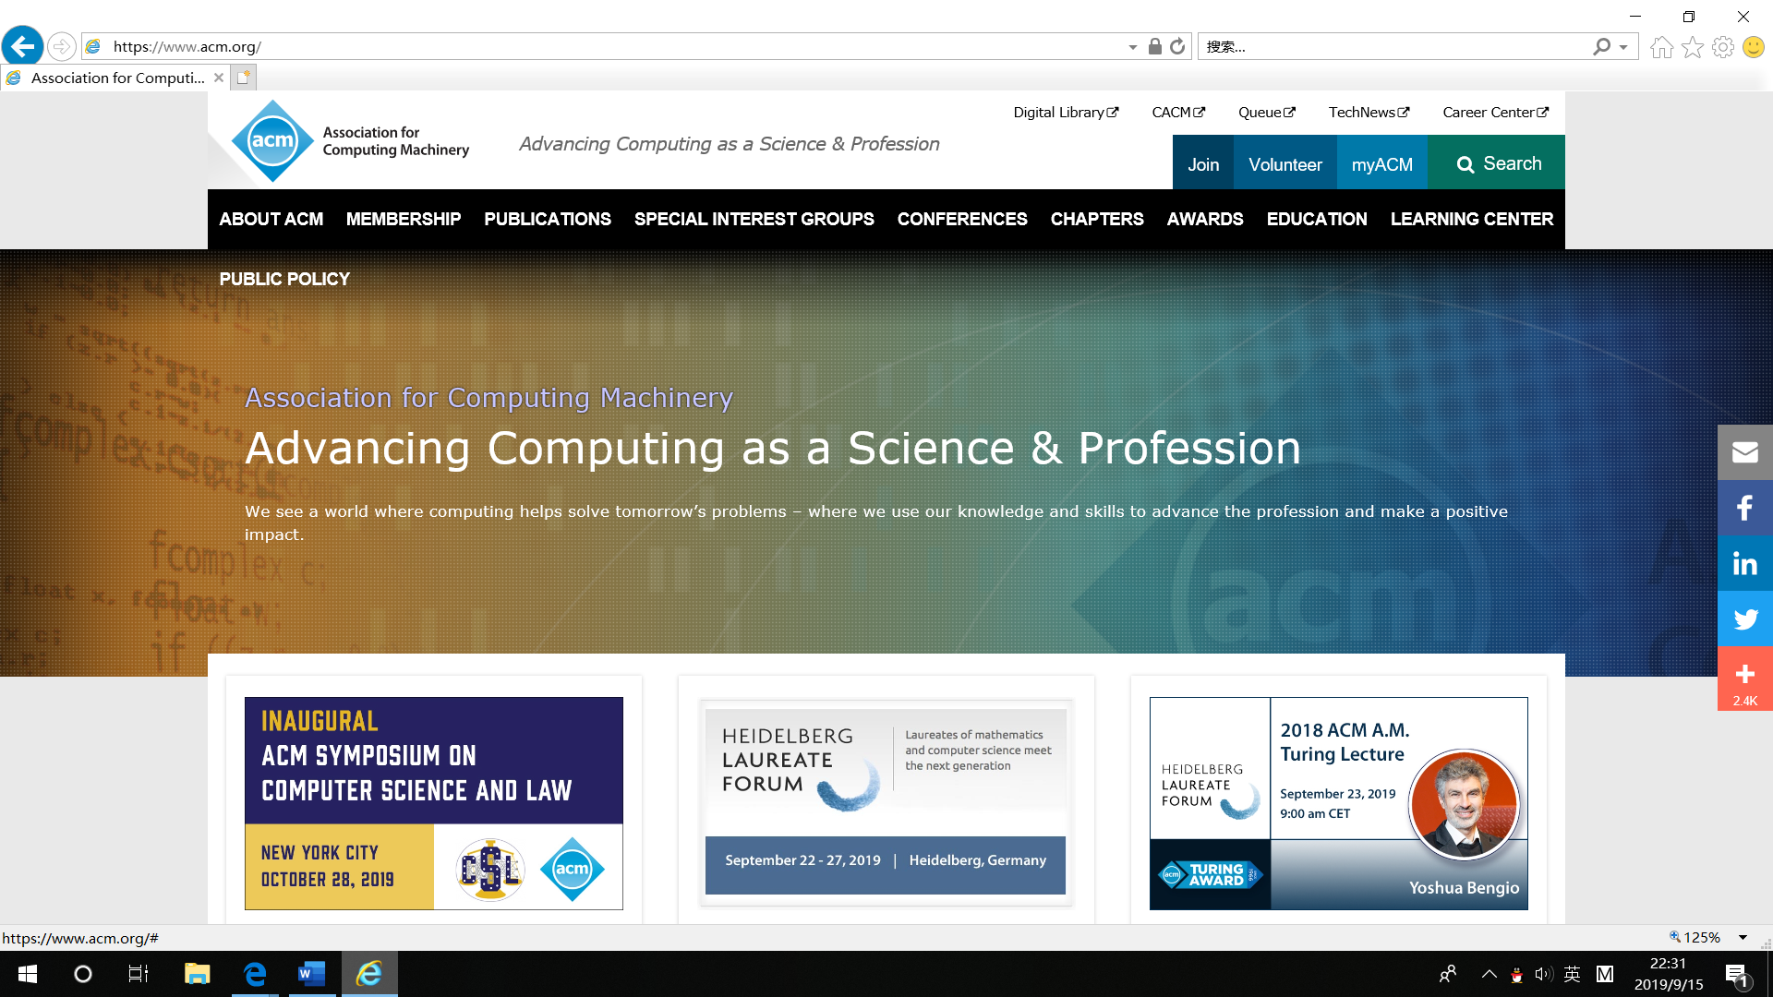

**2) in the firefox 61.0**

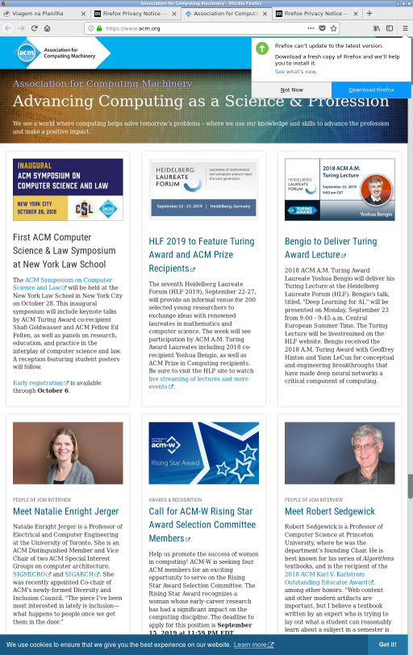

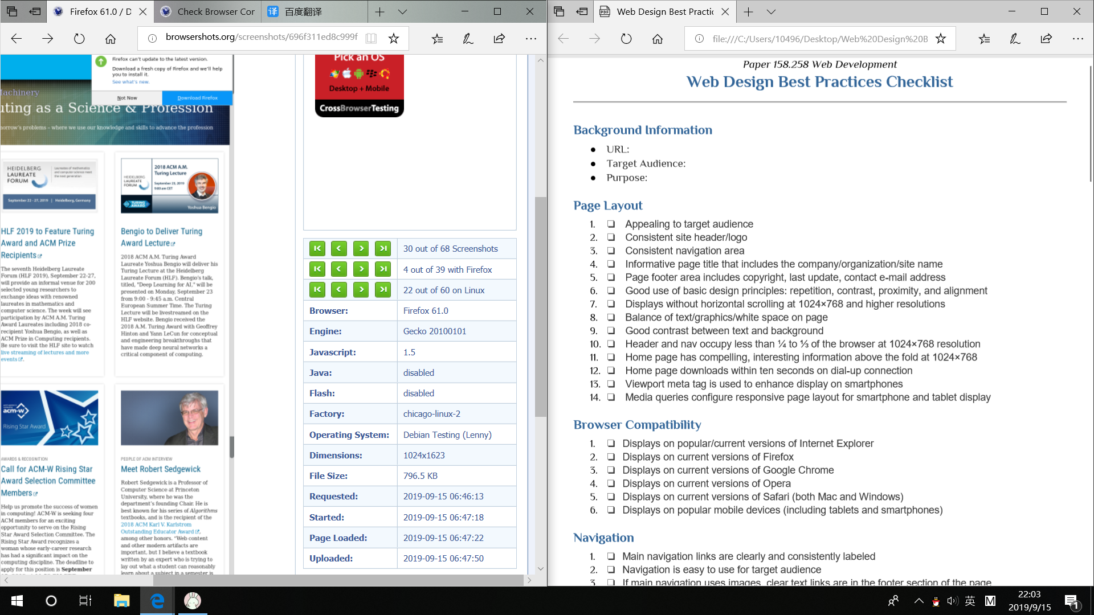

**3）in Goolge Chrome 73.0.3683.86**

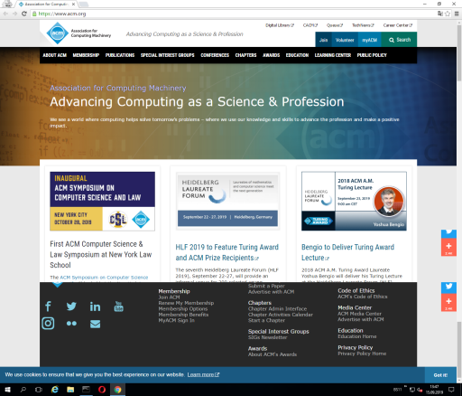

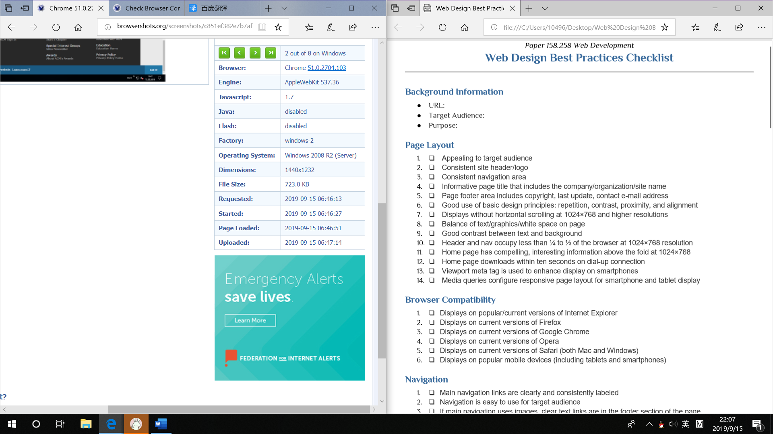

**4）in Opera 58.0.3135.65**

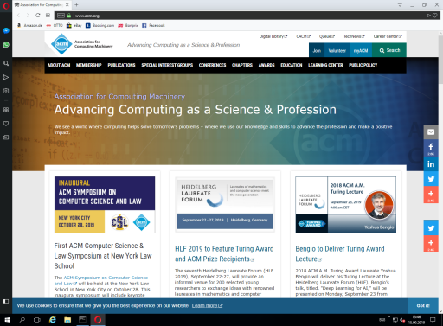

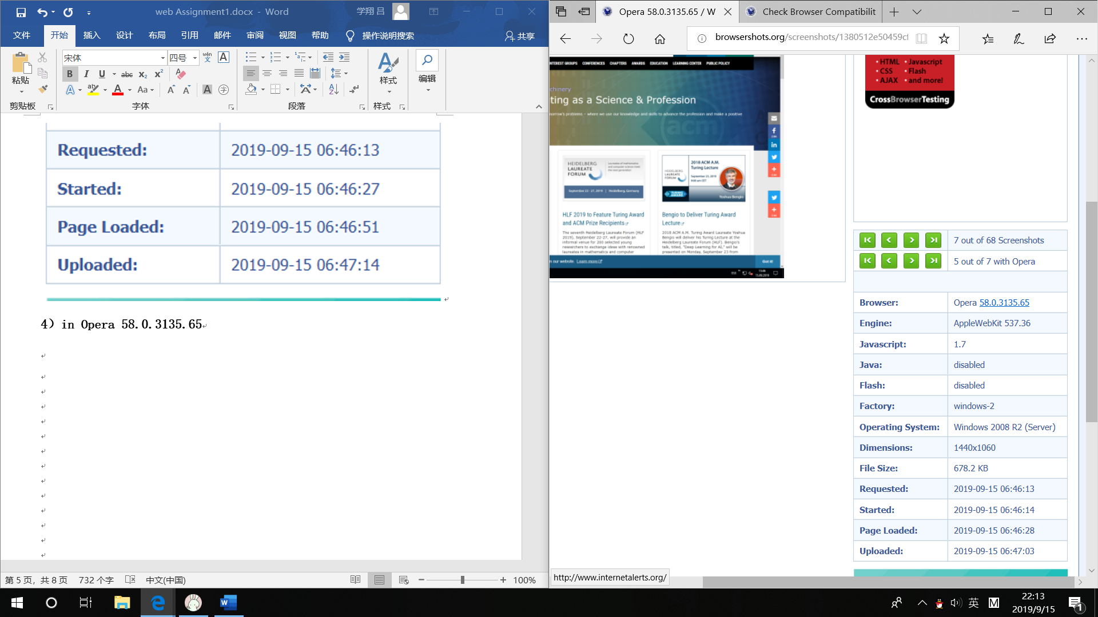

**5) in smartphone**

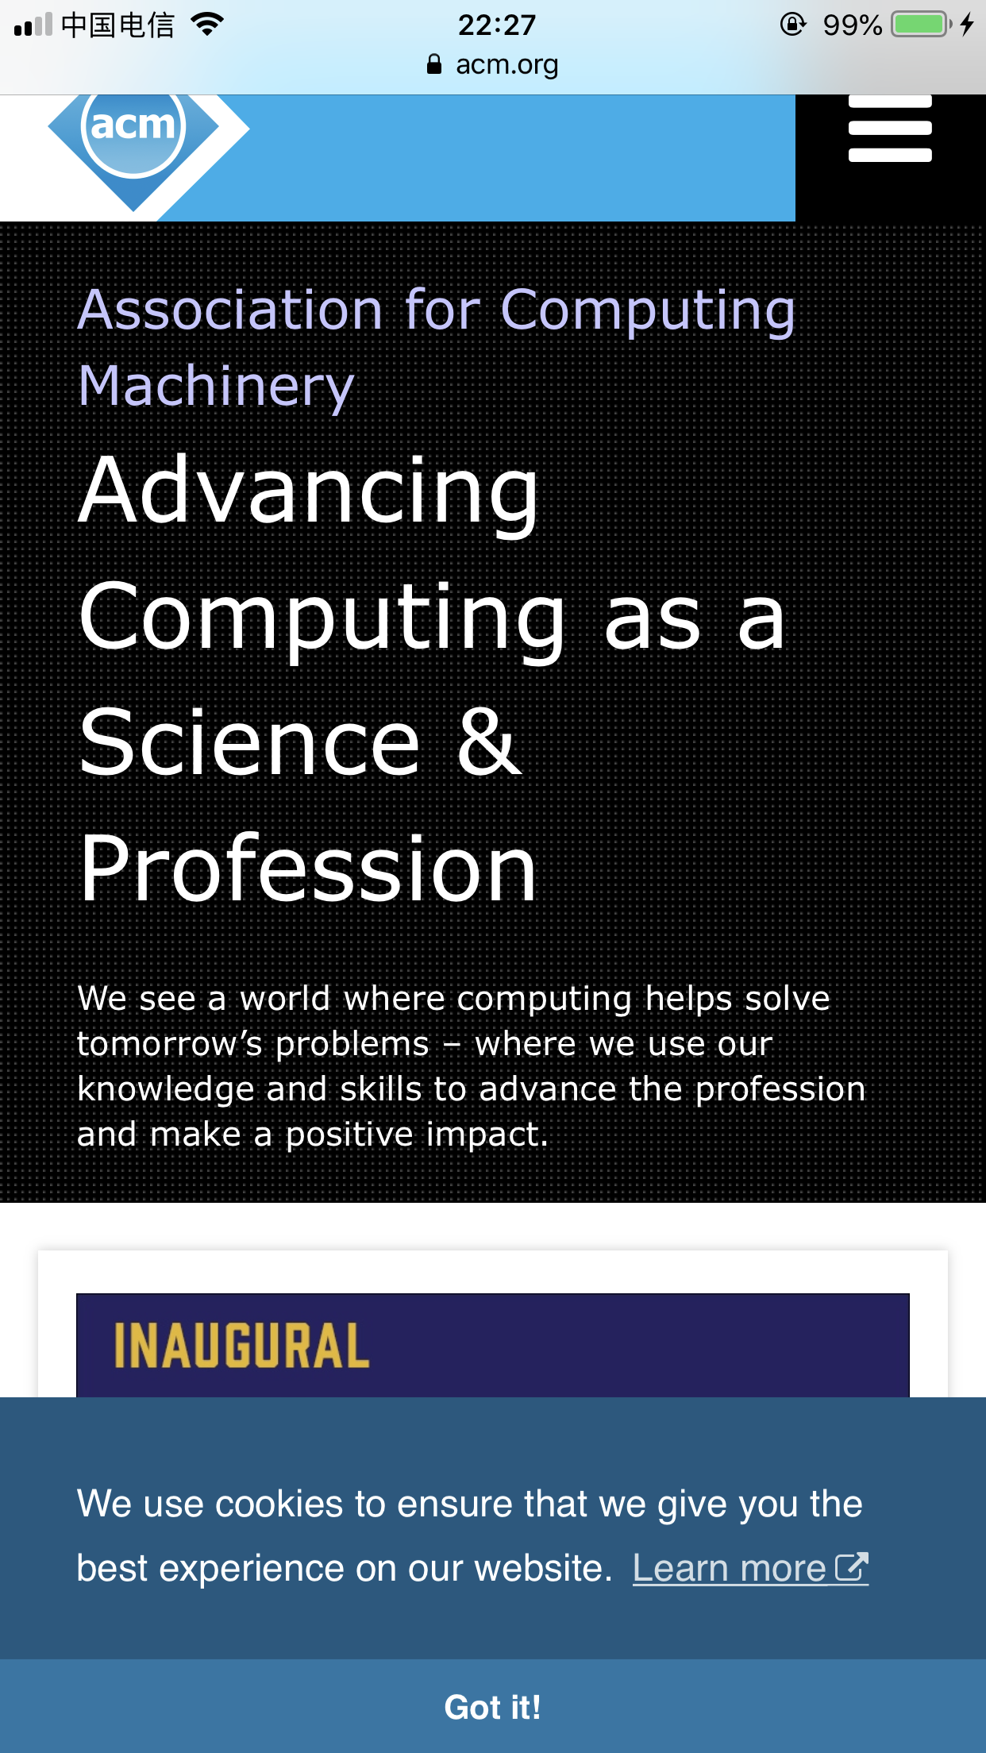

In this kind of browers,they have differenct advantages and disadvantages.

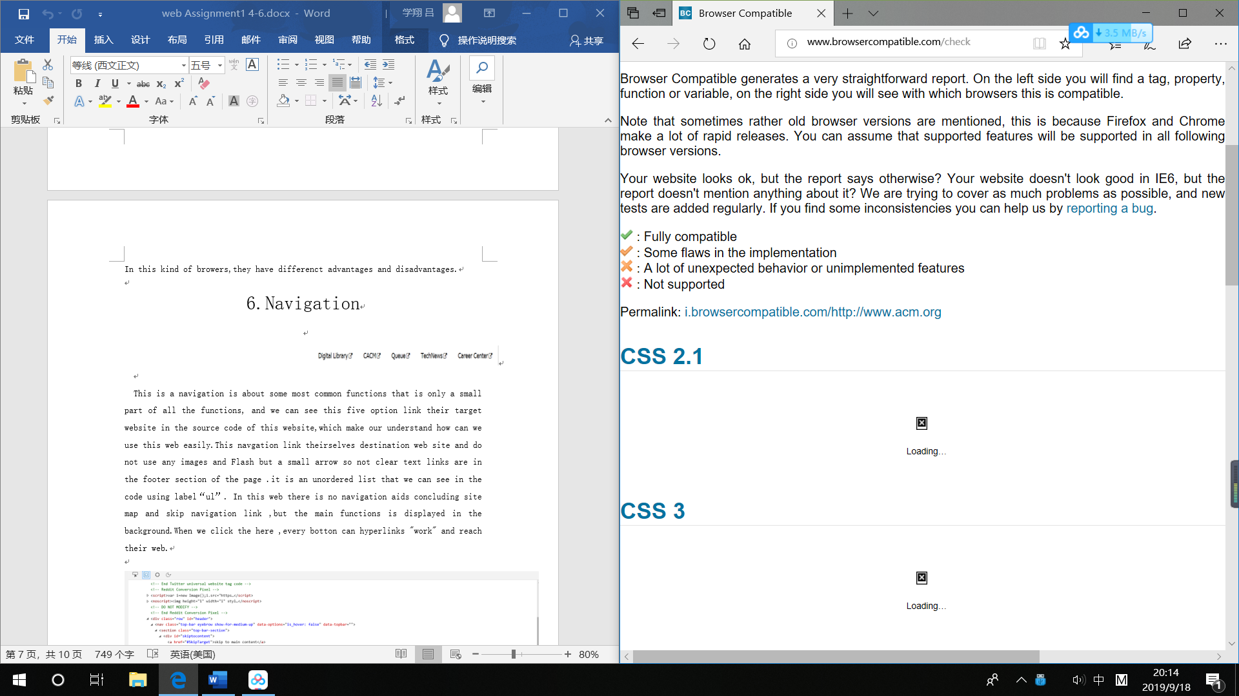

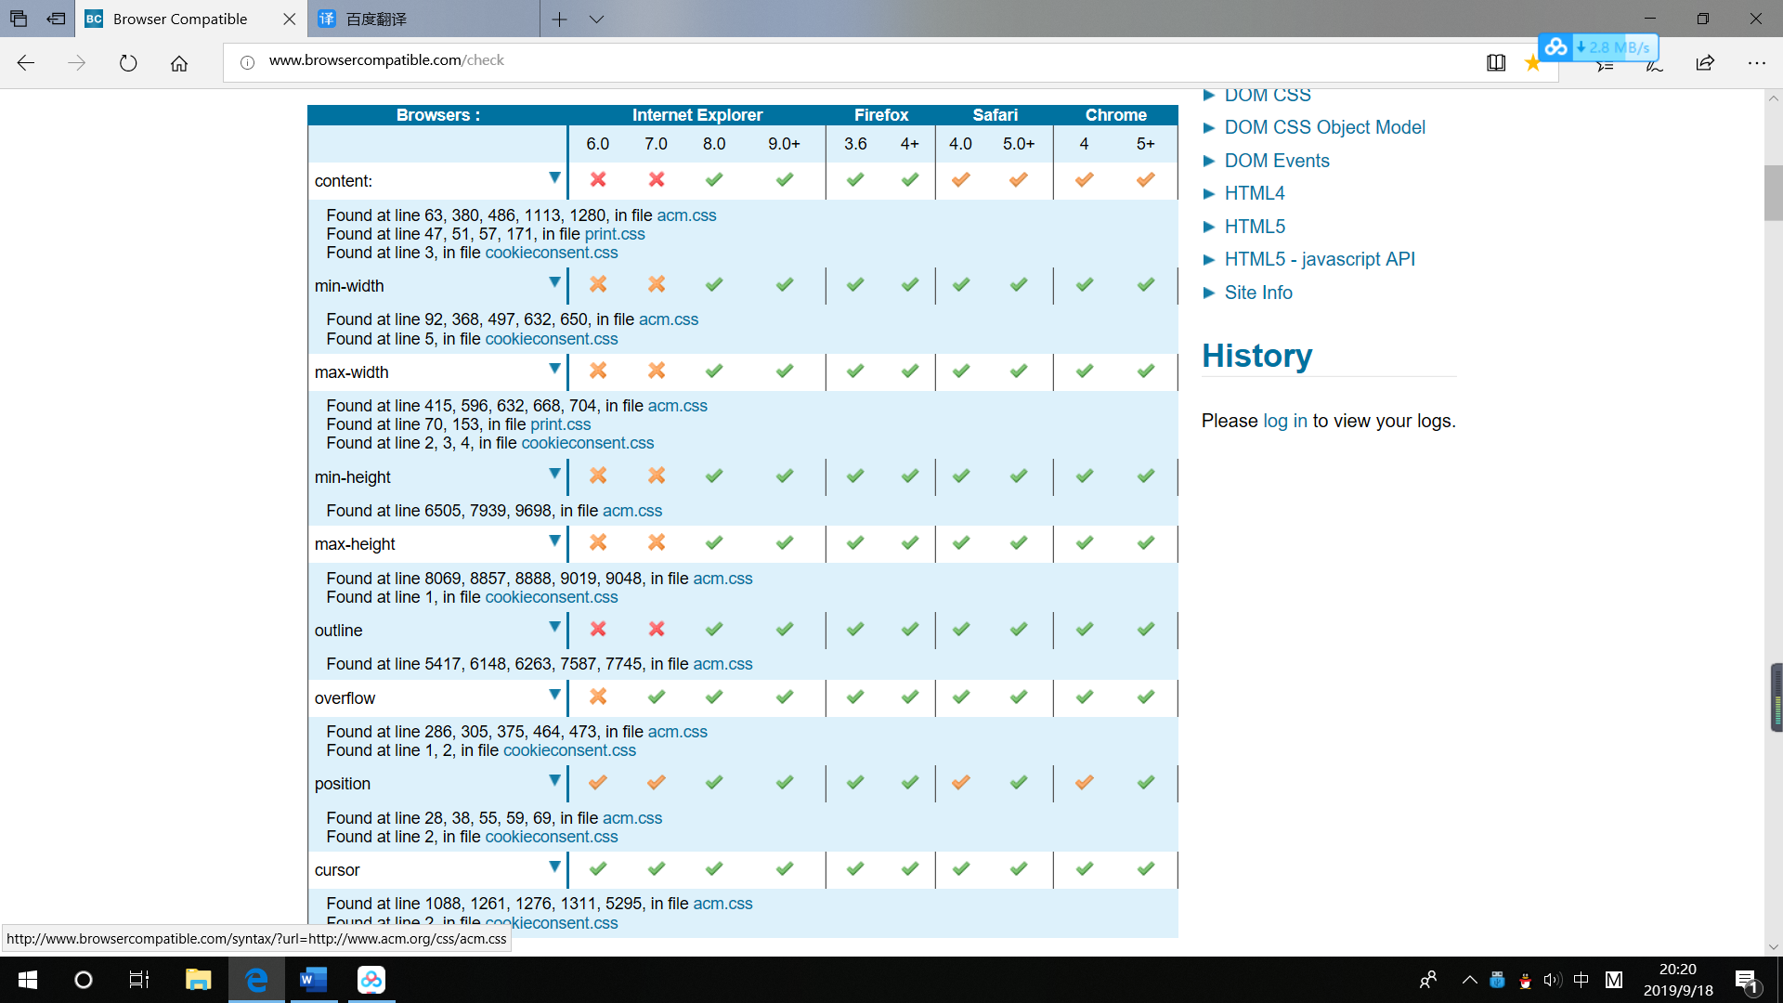

In css2.1, most versions of browsers are compatible with these features, only in Internet Explorer 6.0 and 7.0 can not use this.

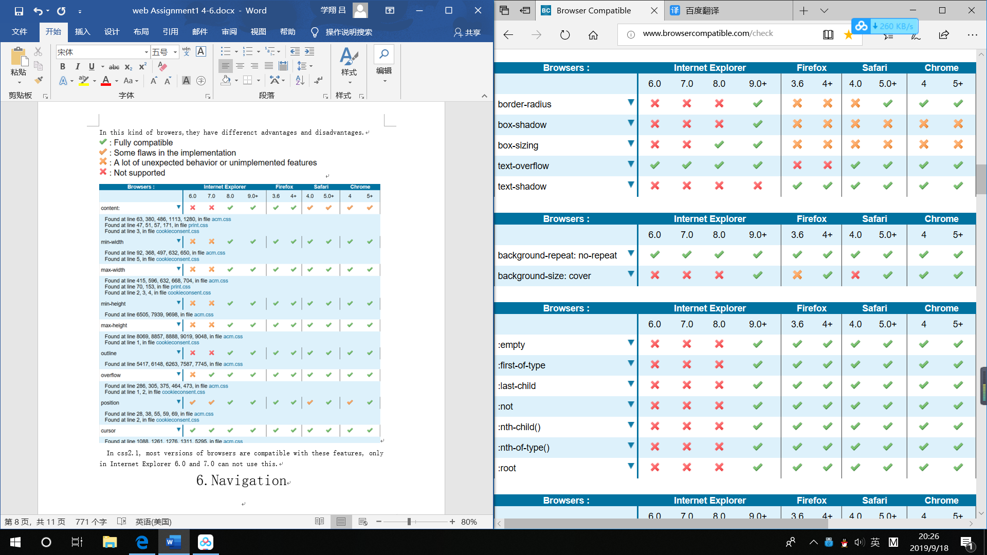

In css3, old versions of browsersInternet Explorer not support to border-radius and in firefox this feature is not supported at all.at box-sizing and box-shadow there are three browers like Firefox Safari and Chrome A lot of unexpected behavior or unimplemented features.

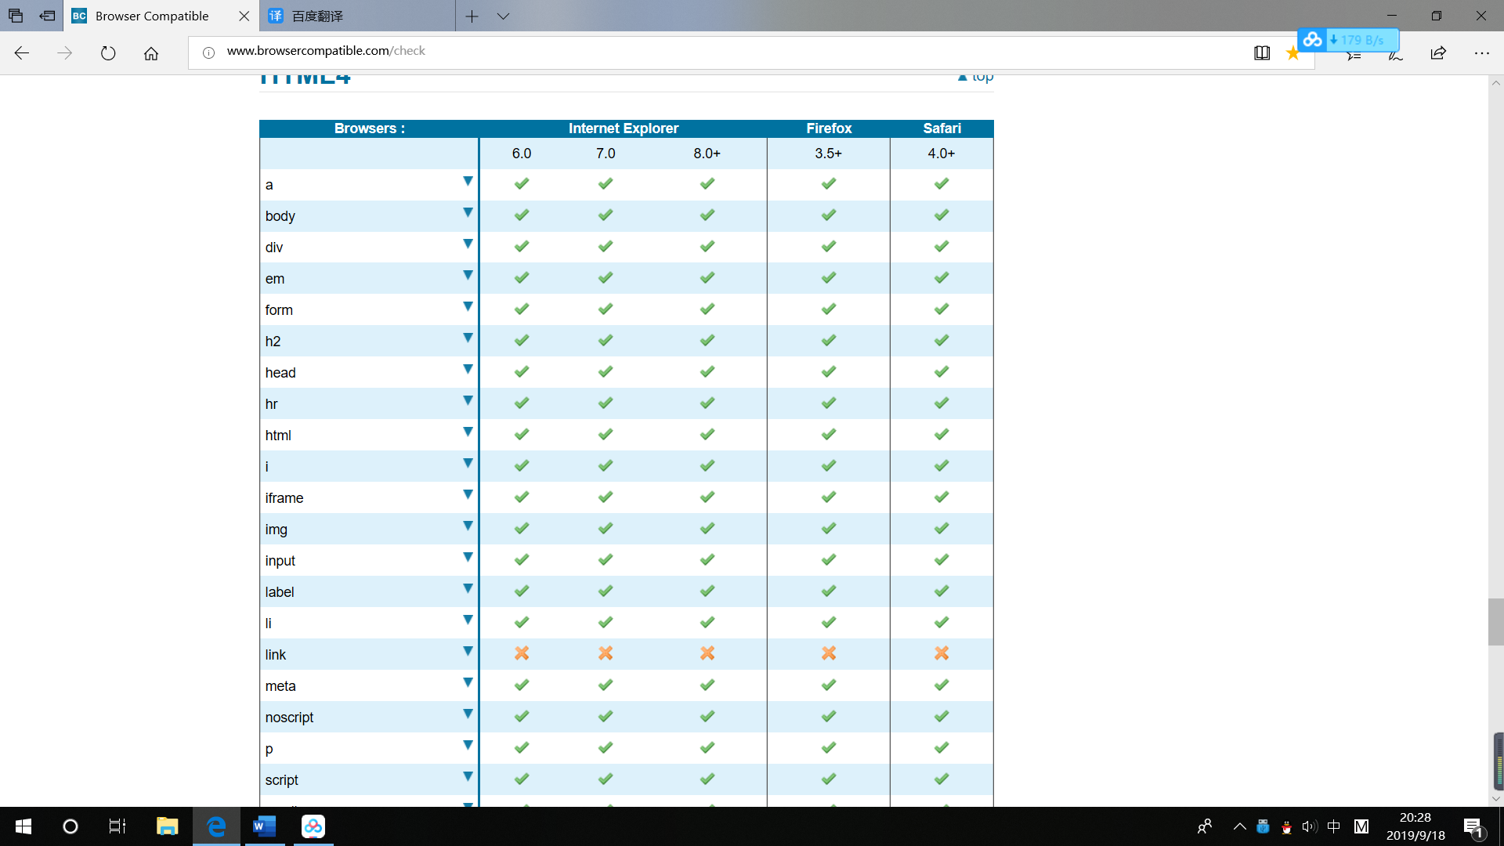

In html4., all browers have all the functions,buy only in the “link” all this three browers do not have this

6.Navigation

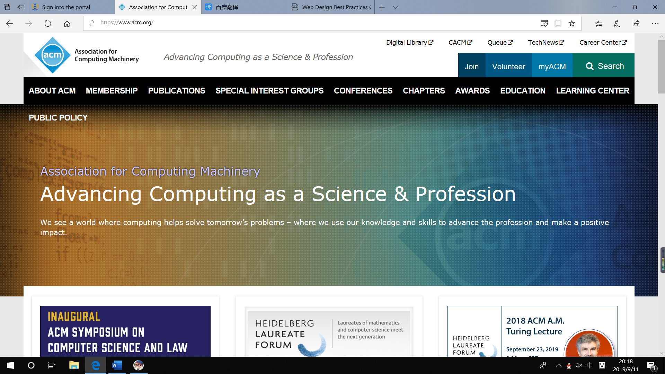

This is a navigation is about some most common functions that is only a small part of all the functions, and we can see this five option link their target website in the source code of this website,which make our understand how can we use this web easily.This navgation link theirselves destination web site and do not use any images and Flash but a small arrow so not clear text links are in the footer section of the page .it is an unordered list that we can see in the code using label“ul”. In this web there is no navigation aids concluding site map and skip navigation link ,but the main functions is displayed in the background.When we click the here ,every botton can hyperlinks "work" and reach their web.

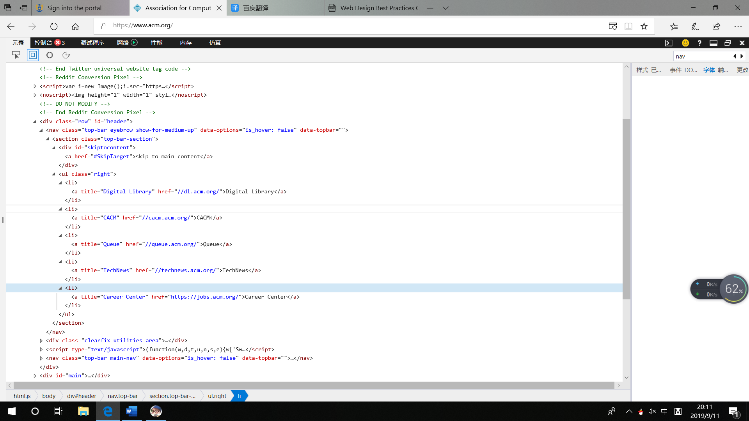

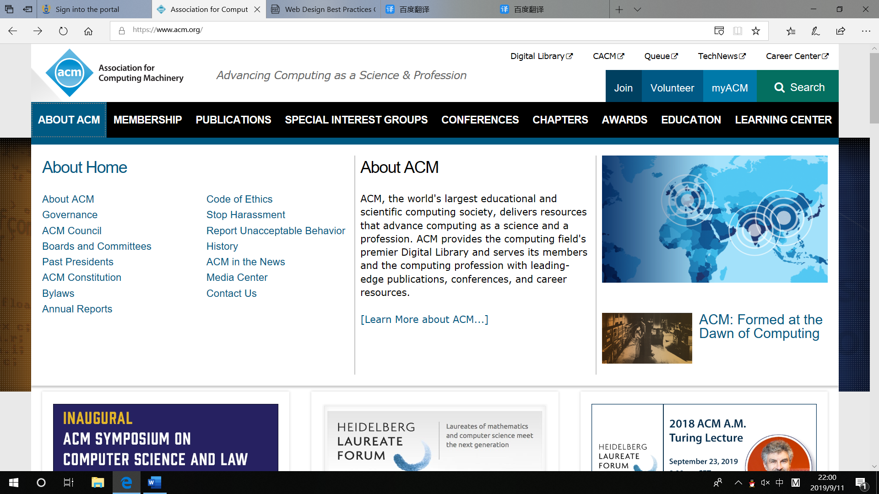

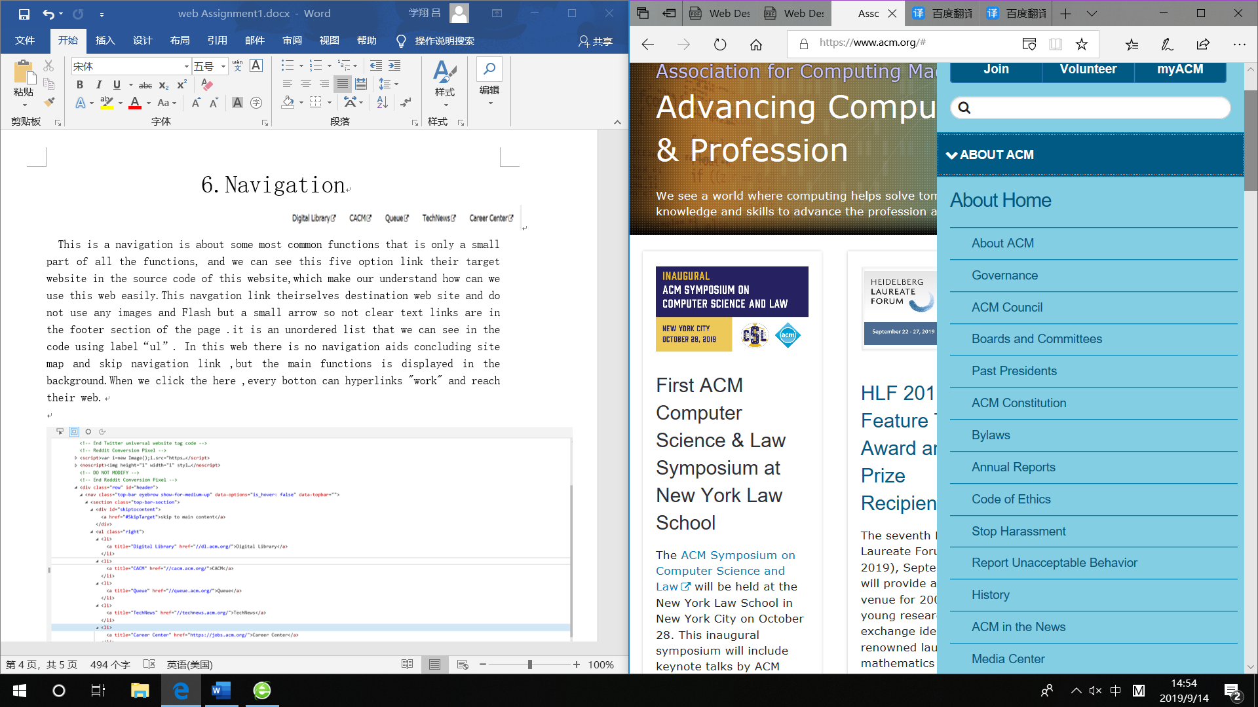

There is another navigation in the web. When we use a different resolution, it has a different representation. I have shown two different representation of it in screenshots. This navigation contains almost all the functions of the website. There are nine headlines, each with many subheadings. Only one of them is discussed here, and the others are similar.

For example, after click the ABOUT ACM, in the “ABOUT ACM” label contain not only have a lot of buttons but also a paragraph describing the main tag in the middle of the list. This can make every freshman find what is their want to find easily, then jump to the destination web. If only the degree label can't understand, you can also see the text in it. Besides, at the far left it has some pictures about this part that also link some webs. When we at the lower resolution the navigation is a spinner no more explanations to save space. They also not use the Flash.

In the source code, we can see both the headlines and the subheadings which are link their own webs use” ul” label that is unordered list. And no navigation aids were used, but everyone can easily understand it.

When we use the function of it, we direct click the button, each of button can used and no one is broken.

